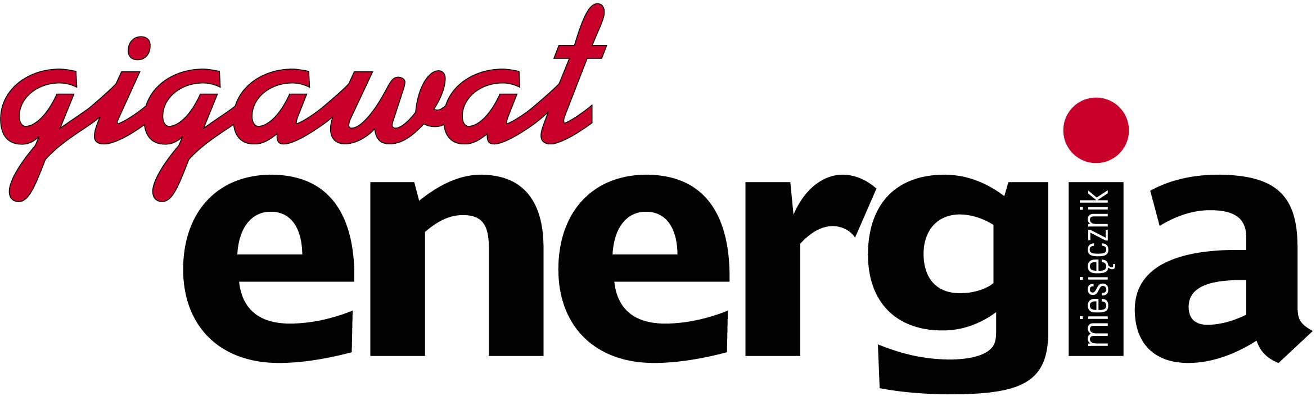

WELCOME TO POLAND’S ENERGY JOURNAL!

We are proud to introduce “ENERGIA GIGAWAT”, Poland’s most prestigious national magazine for the energy, coal, oil and gas industry. This monthly publication is designed for the country’s top professionals, reaching more than 5000 middle and upper level management employees in approximately 1500 companies. Hopefully you will enjoy reading this fascinating magazine and get a better understanding of events in this part of the world.
We look forward to hearing from you.

SPECIAL PROMOTION OFFER
PAGE: | PRICE in Polish zloties (PLN)
Standard page (odd) or promotion article | 3100
Standard page (even) or promotion article | 3000
2 standard pages (odd and even) | 5000
1/2 of standard page (odd) | 1600
1/2 of standard page (even) | 1500
Modules  (one module 1/9 of standard page - 54mmx76mm) | 600  (price per module)
Front cover | 11000
Inside back cover (full page) | 3500
Inside front cover (full page) | 5000
Back cover (full page) | 8000
PRICES DO NOT INCLUDE 22% VAT
ALL PRICES ARE IN POLISH ZLOTY
Discounts are available for three or more advertisements purchased in one year:
- three advertisements - 5% discount
- six advertisements - 10% discount
- twelve advertisements - 25% discount.

NOTE: International subscriptions, one-year cost only $ 73,5 including mailing anywhere in the world
($ 99,75 - if prioritaire air mail).

_________________________________________________________________________________________
Publisher: Agent PR ul. Krowoderska 58 lok. 18
NIP 676-101-97-20, Regon 350821906 31-158 Kraków, POLAND
Account in BPS SA CODE SWIFT: POLU PL PR, number: 85890006-153487-27003255
tel/fax (+48-12) 632-47-27, tel. 292-20-39 e-mail: energia@staszica.com
www.gigawat.net.pl

